Lab 5: Basic SOHO Router Configuration Plus Explore ARP Protocol and Ethernet Frames
10 Marks

What you will do:
- You will build, configure, and test a Wired (Ethernet) network that you will connect to the lab’s existing Eagle Network.
- Capture/explore/analyze ARP requests/responses.
- Capture/explore/analyze Ethernet frames.
- Calculate the size of various Ethernet frame fields.
- Implement basic router configuration:
  - Connect to the router’s management web page.
  - Configure a dynamic IP on the Internet interface.
  - Modify the router’s IP address.
  - Modify the router’s name.
  - Set time zone.

Things that you will need to know or learn:
- Identify and understand the different layers of addressing necessary to a successful communication.
- The general purpose and format of an ARP message.
- The format and purpose of Ethernet frame header and trailer fields.
- Writing simple Wireshark expressions to filter frames.
- Understand the information provided in the Wireshark Details Pane to extract addressing information as well as being able to map protocols to their OSI or TCP/IP network model layers.
- How to read Ethernet II header information from a Wireshark capture including the Ethertype values.
- The Ethertype values for Ethernet II frame encapsulating IPv4 and ARP.
- Extracting ARP request message details from Wireshark.
- Determining your network adapter’s MAC address.
- Determining your default gateway’s IP and MAC address.
- How to look up the manufacturer of a network interface based on the OUI of the assigned MAC address.

What you need to submit and when:

Demo in class to your lab instructor

Required Equipment:
  - Network cables: one straight-through and one crossover
  - One Linksys router, one laptop
  - Wireshark is installed and working on your laptop.
  - Access to the Eagle Network (red network jack)

Task 0: Preparations
1. This lab is to be completed individually
2. Disable the Wireless Network, VM, Anti-virus and WDF. Your only connection to the network must be via the Ethernet (wired) interface.
3. Do not start until you have completed ALL steps in this task.

Task 1: Build, Configure, and Test Local Network
In this task, you will build, configure, and verify the proper operation of the network topology shown in “Lab 05 –
Network Topology”. The network you are building consists of your LAN network which you will connect to the lab’s
Eagle network. Note that your LAN network simulates a small home/office network whereas the Eagle Network simulates an Internet Service Provider (ISP)
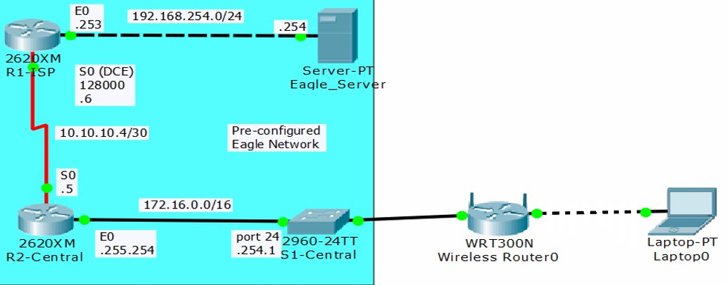

How many networks do you see in this topology? 4 NETWORKS (1 mark)
Do not start Task 1 until you have completed all Task 0 steps.
- Reset the router (Linksys) to factory defaults.
- Connect your laptop to any of your Linksys switch ports (blue port, 1,2,3,4) using the appropriate cable.
- Connect your Linksys router’s Internet port (yellow port) to the “Red” jack on your desk. This is your connection to S1-Central and the Eagle Network. Make note of the jack number you are using. This will be used to create your IP addresses.
- Confirm basic connectivity by making sure you can successfully ping your default gateway. Do an ipconfig to determine your default gateway address.
What is the Eagle server DGW? 192.168.1.1 (1 mark)
- Open a web browser and enter http://192.168.1.1 (your DGW) in the address bar to connect to the router’s (your router) configuration page.
- You should see a page like the one shown below. Click “Continue with an open and unsecured network.”
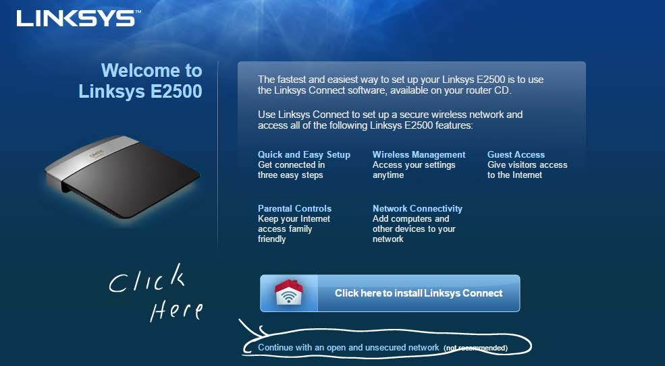
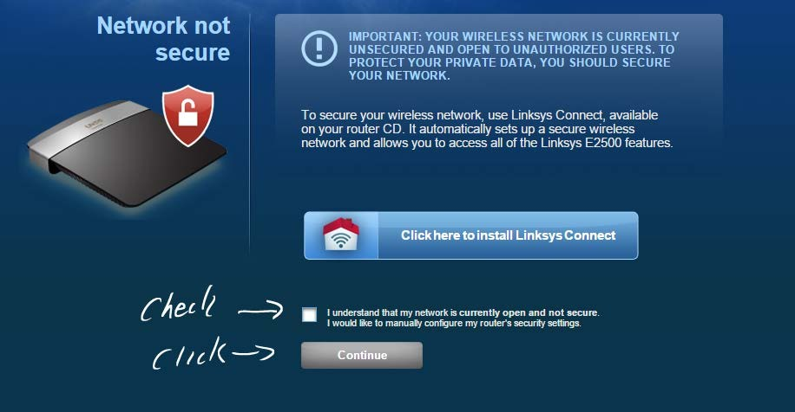
You will now get another warning screen. Just check the box that says you understand and click continue.
- Login into the router using the username/password of admin/admin.
- You will now get another warning, check the “Do not show me this again” box and click OK.
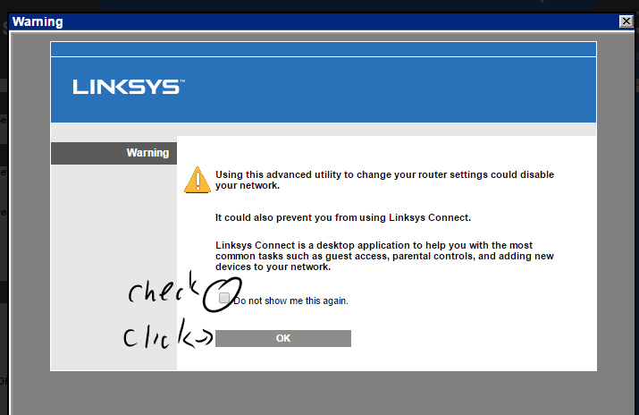
- If the OK button doesn’t work just close the dialog box.
- You should see a page that looks like this.
- You will now perform some simple configuration tasks.
  - The language is set to English.
  - Under “Internet Setup”, set the Internet Connection Type (WAN) to “Automatic Configuration DHCP.”
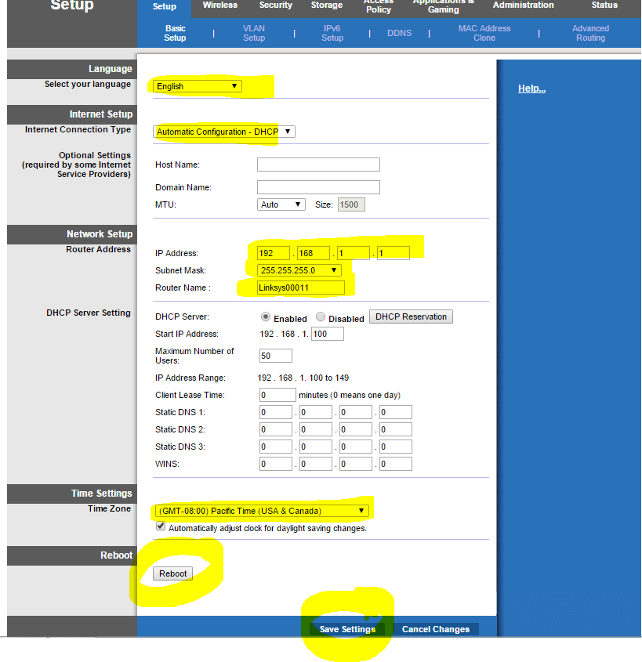
  - Under the “Network Setup tab”, (LAN):
See step 13 for the custom numbers
and name you need to use here
Red jack number
Yellow port

12-A. Set the Router Address to 192. 168.NN.1, NN= Red jack number you are using. This will be
the router’s IP address on your LAN. (DGW)
12-B Set the Subnet Mask to 255.255.255.0
12-C. Set the “Router Name” to your Algonquin User ID ex: smit0099
  - Under Time Settings, set the Time zone to (GMT -05:00 Eastern Time (USA and Canada). Make sure you select “Automatically adjust the clock for daylight savings changes”!
  - Leave everything else at the defaults.

Take a Screenshot here (1 mark)
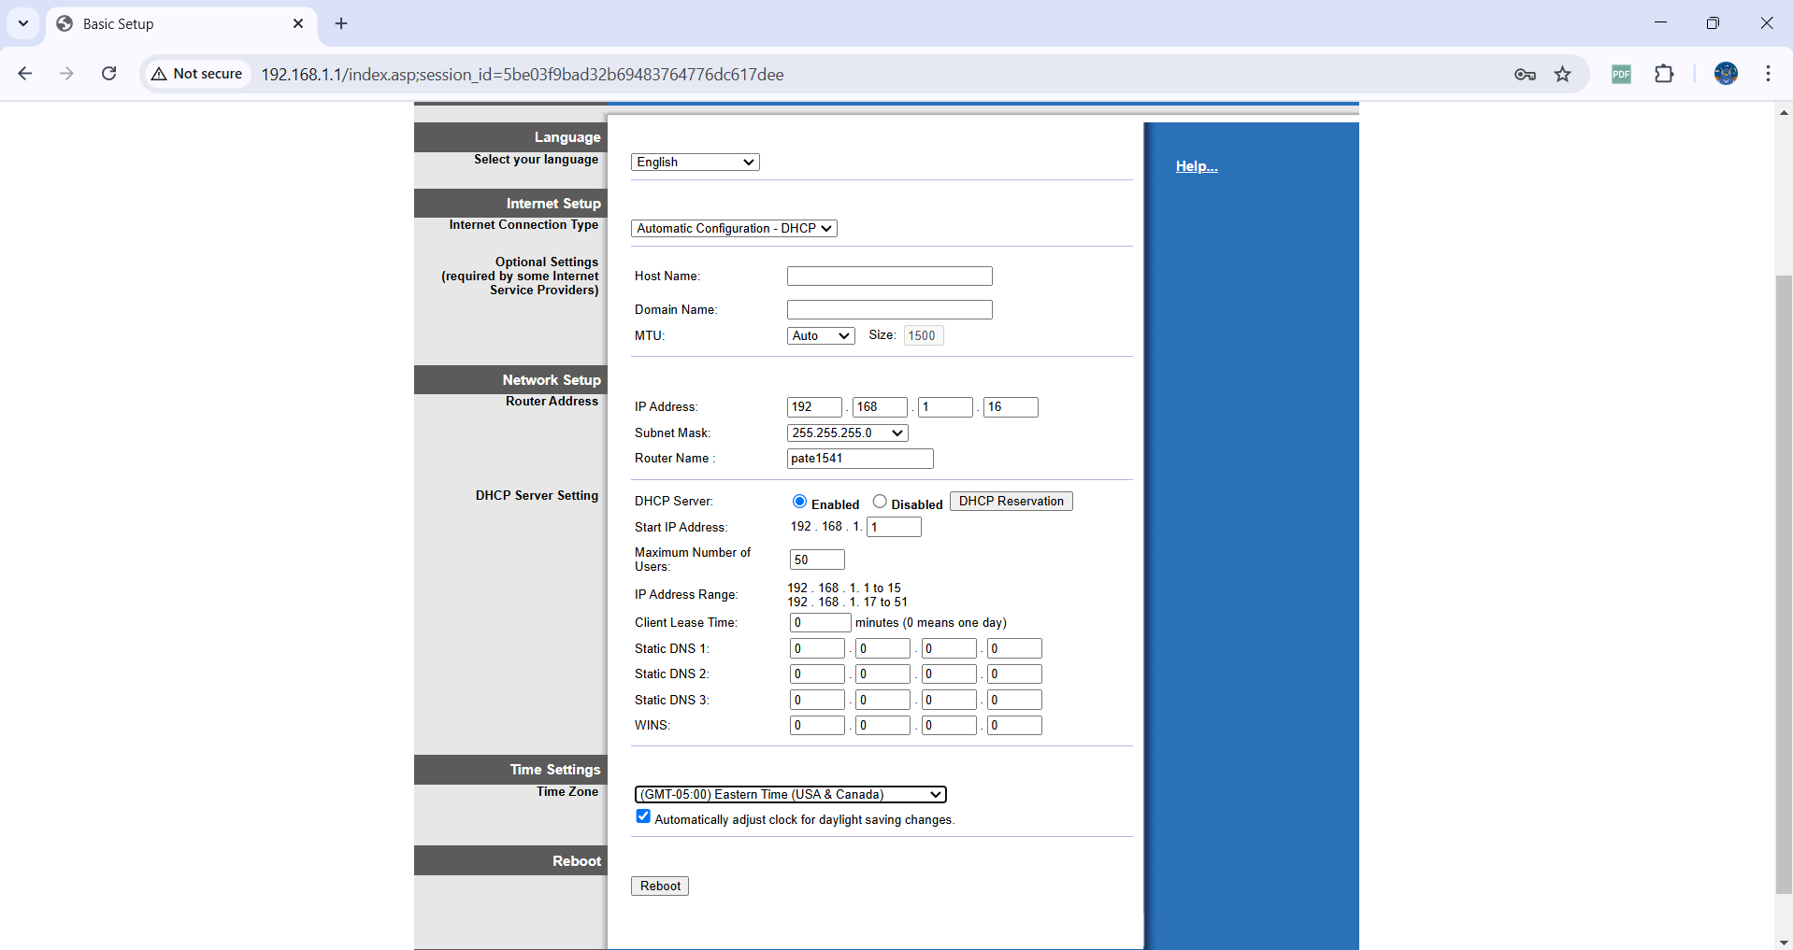

  - Now click “Save” your settings. Your router will now reboot.
- Once the router has rebooted (will take about 60 to 90 seconds to reboot), check your laptop’s IP address. Your default gateway should be the same as the IP you set in step 12-A, if it’s not released renew your IP address (ipconfig/release followed by ipconfig/renew).
- Do not proceed until you can ping your default gateway at 192. 168.NN.1

Task 2: Capture/Analyze ARP Request
In this task, you will capture the traffic resulting from sending a message to a remote network. You will focus on the ARP requests/replies that were generated as a result of this remote communication.
- Start a Wireshark capture on your laptop.
- Open a Command Prompt window as Administrator (Run as Administrator) and type in the commands below one at a time:
  - arp –d *
The command clears any entries you have in your ARP cache, thus forcing ARP requests to be generated.
Note: if you see some entries in the ARP table, that is normal, because your laptop is talking to the router constantly.
  - Ping 192.168.254.254 (eagle server). The ping MUST BE SUCCESSFUL!
Take a screenshot here (1 mark)
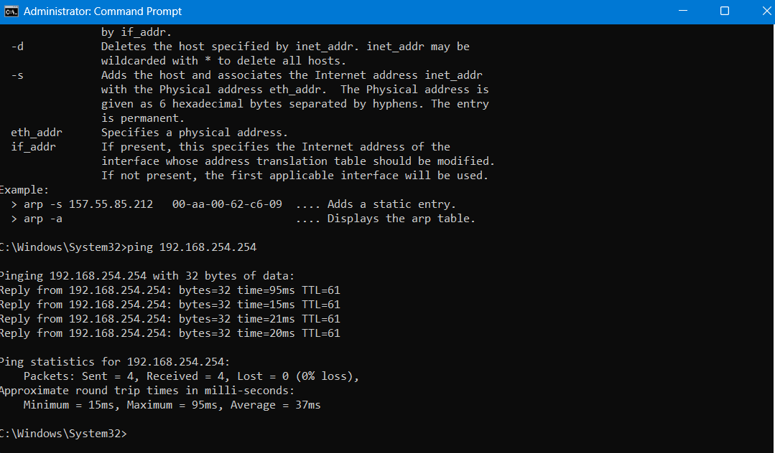
- Stop the capture.
- You will now examine the capture to ensure that the desired traffic has been captured.
- Filter with ARP.
- First, you are looking for an ARP request message having the following characteristics:
  - Source MAC: your laptop’s Ethernet interface MAC address
  - Destination MAC: (ff:ff:ff:ff:ff:ff), what type of frame is this? broadcasting (1 mark)
  - Info Column
    - Who has h.i.j.k? Tell w.x.y.z
      - where w.x.y.z is your laptop IP address.
      - h.i.j.k is the IP address of your default gateway.
- Second, you are looking for the ARP response to the ARP request of step 6. It will have the following characteristics:
  - Source MAC: your gateway’s Ethernet interface MAC address
  - Destination MAC: your laptop’s Ethernet interface MAC address
  - Info Column
    - h.i.j.k is at 0a:1b:2c:3d:4e:5f.
      - where 0a:1b:2c:3d:4e:5f is your default gateway MAC address.
      - h.i.j.k is the IP address of your default gateway.
- take a screenshot of the Arp request and reply here (1 mark)
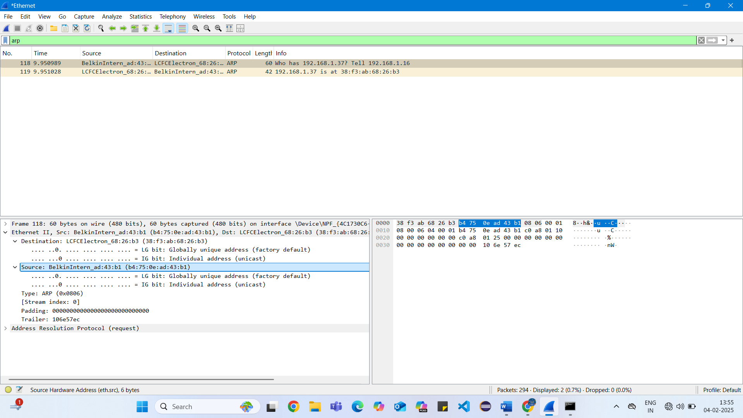
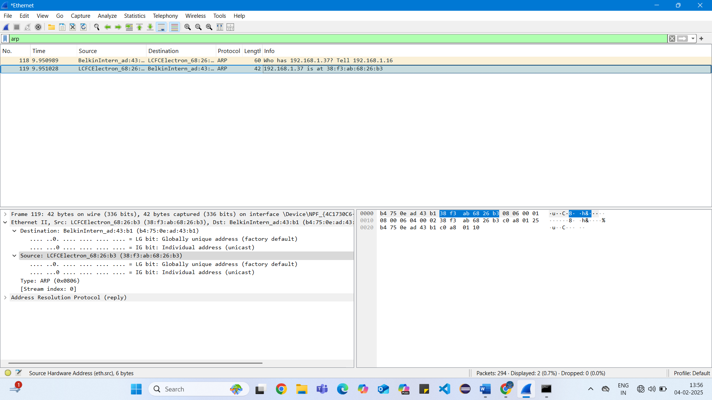
- Save the WS.

Task 3: Capture and examine an HTTP session to the Eagle Server
- You are now going to open a web page on the Eagle Server
- First, let’s make sure we can reach the Eagle Server. Open a command prompt and ping 192.168.254.254. Make sure the ping is successful before proceeding. If not ask your instructor for help.
- Read the following steps before starting them so you know what to do.
  - Clear your ARP cache.
  - Start a Wireshark capture using your Ethernet Adapter
  - Open your web browser and enter the URL http://192.168.254.254
What is this 192.168.254.254 IP address to which device does this IP belong? Eagle-Server (1 mark)
  - Once the page has loaded, stop your Wireshark Capture
- Examine your Wireshark capture to ensure it has the following frames.
  - ARP request and reply for 192. 168.NN.1
  - HTTP Get a request with the destination IP 192.168.254.254
  - HTTP Response from the IP 192.168.254.254
  - If it does, then take a screenshot here (1 mark) If it doesn’t repeat Step 3
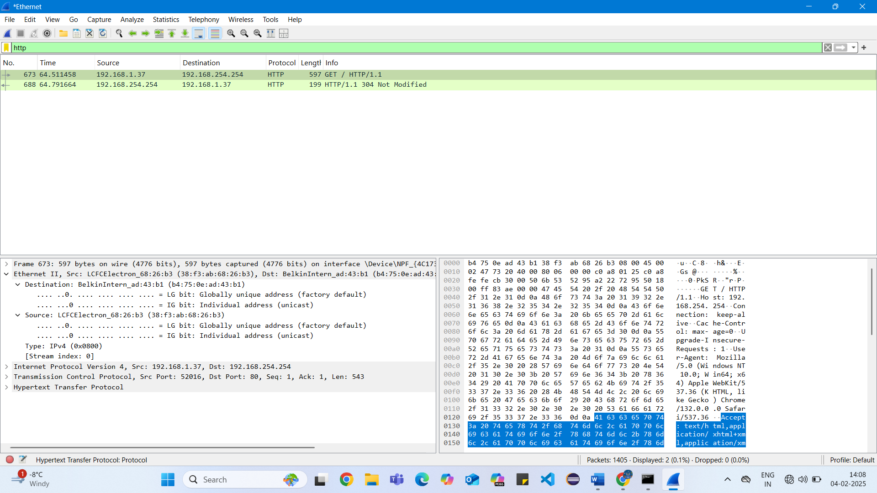
- Answer the following questions:
  - Why did your laptop use ARP for the MAC address of 192.168.NN.1 when trying to reach 192.168.254.254? (1 mark)
Because it needed to send the data through the default gateway.

  - Examine the destination MAC address in the HTTP Get request. Did the Mac address change (1 mark)
Yes, the Mac address changed.

Task 4: Backup your router’s configuration
- Use your browser to connect to your router’s configuration page.
- Click on the Administration Tab
- Click the “Back up Configuration”
- Your configuration should download to your laptop in your default downloads folder.
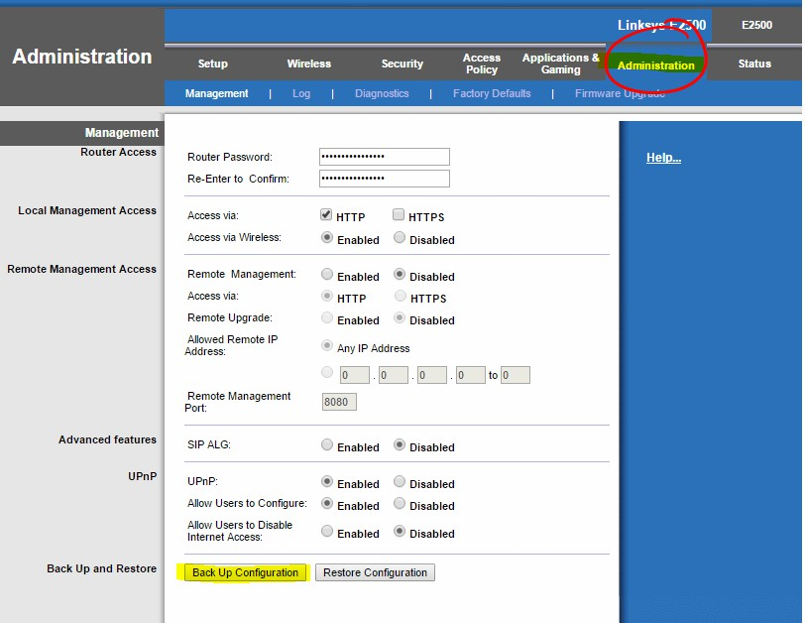
- Locate the file and rename it to “task4.cfg” (1 mark)
Demo your lab and save the file to your lab instructor.

